**Project Title: Flight Delay Prediction Project**

**Project Scope:**

The scope of this project encompasses the analysis of historical flight data, weather conditions, and other relevant factors to build a robust prediction model. The system will offer real-time predictions, empowering airlines and passengers to make informed decisions and take proactive measures to mitigate the impact of potential delays.

**Problem Statement:**

Flight delays lead to inconvenience for passengers, financial losses for airlines, and operational challenges for airports. Existing prediction models often fall short in accuracy due to the complex interplay of multiple variables. This project addresses these limitations by employing advanced machine learning techniques to create a more reliable and precise flight delay prediction system.

**Objective:**

* Build advanced machine learning models that analyze historical flight data and relevant factors (e.g., weather conditions, air traffic) to predict flight delays with a high level of accuracy.
* Assist airlines in optimizing their operations by providing early insights into potential delays. This includes optimizing crew schedules, resource allocation, and maintenance planning to minimize disruptions.
* Empower passengers with accurate and timely information about potential delays, allowing them to make informed decisions, adjust their plans, and reduce frustration caused by unexpected delays.

**Methodology:**

* Problem Definition and Goal Setting
* Data Collection and Preparation
* Exploratory Data Analysis (EDA)
* Model Development
* Model Evaluation
* Deployment and Monitoring
* Documentation and Knowledge Sharing
* Continuous Improvement.

**Tools and Technologies:**

* **Data Preprocessing:** Data Cleaning, Feature Engineering, Normalization/Standardization, Encoding Categorical Variables
* **Exploratory Data Analysis (EDA):** Statistical Analysis and Data Visualization using libraries like Matplotlib, and Seaborn to visualize data distributions, correlations, and trends.
* **Model Development:** Machine Learning Algorithms Deploying various regression/classification algorithms suitable for predicting flight delays and selecting the best model for the project data from Random Forest, Gradient Boosting, Support Vector Machines (SVM), and Logistic Regression Model.
* **Model Evaluation:** Cross-validation, Evaluation Metrics such metrics like classification metrics like accuracy, precision, recall, and F1-score were used for the project.

**Key Findings:**

The Total number of flights recorded during the period of observation is 1048575.

The Total Number of Delayed flights recorded is 430071.

The percentage of Flight Delay recorded is: 41.01 %

**Visualizations:**

Air-System-Delay, Airline-Delay, and Late-Aircraft-Delay collectively contribute to 62% of all delays. Specifically, Air-System-Delay accounts for 22%, Airline-Delay and Late-Aircraft-Delay each contribute 20%. Security-related delays represent a minor fraction at 0.1%, while approximately 33.9% of delays stem from other unspecified factors within the dataset.

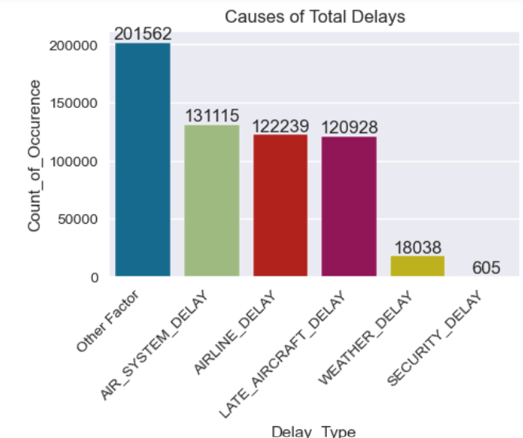

Day-wise Flight and Delay Distribution:

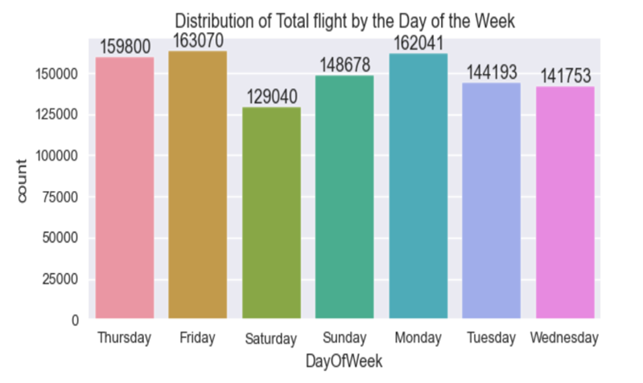

Fridays witness the highest number of recorded flights, whereas Mondays experience the highest frequency of delays. Moreover, there exists a correlation between the volume of flights on a given day and the incidence of delays, with a proportional increase in delays corresponding to an increase in flight volume

**Airline Performance:**

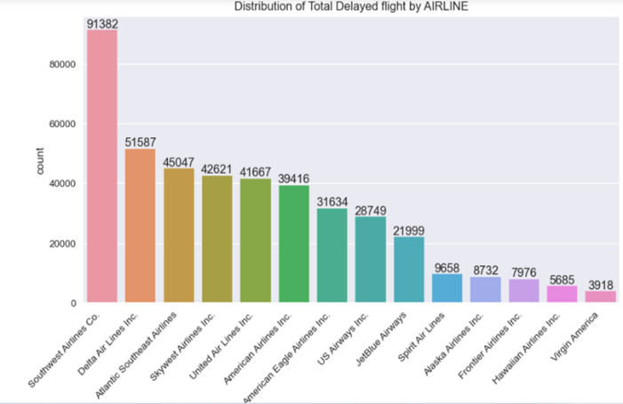

Southwest Airlines Co. emerges as the leader in both total flights operated and delayed flights recorded. However, Frontier Airlines Inc. exhibits the highest percentage ratio of delayed flights to total flights operated, standing at 54.37%. In contrast, Southwest Airlines Co. experiences delays in 39.8% of its flights, whereas American Airlines boasts the lowest delay percentage at 29.5%.

**Airport Performance:**

* Hartsfield-Jackson Atlanta International Airport handles the highest volume of flights and concurrently records the most delayed flights. However, the delay percentage per flight operated at this airport stands at 20.7%. In contrast, despite Guam International Airport managing a significantly smaller number of flights (61), it reports a delay percentage ratio of 30.43%.

**Recommendations:**

**Day-Specific Strategies:** Given the higher incidence of delays on Sundays despite lower overall flight volumes compared to Thursdays, airlines should implement targeted strategies to address potential bottlenecks and operational challenges on Sundays. This might involve optimizing staffing levels, enhancing ground operations, and prioritizing maintenance schedules on Sundays to minimize delays.

**Root Cause Analysis and Mitigation**: Understanding the primary causes of delays, such as Air-System-Delay, Airline-Delay, and Late-Aircraft-Delay, enables airlines to focus resources on addressing these specific issues. Implementing proactive maintenance schedules, investing in infrastructure improvements, and optimizing flight scheduling algorithms can help mitigate the impact of these delay factors.

**Airline Performance Optimization**: Airlines should analyze their delay patterns and compare them against industry benchmarks to identify areas for improvement. This may involve optimizing fleet utilization, enhancing crew scheduling algorithms, and investing in technology solutions to streamline operations and reduce delays. Additionally, benchmarking against peers, such as Frontier Airlines Inc. and American Airlines, can provide valuable insights into best practices and areas for improvement.

**Airport Collaboration and Performance Improvement**: Collaboration between airlines and airports is critical to improving overall operational efficiency and reducing delays. Airports can invest in infrastructure upgrades, implement advanced air traffic management systems, and optimize ground handling processes to minimize delays. Additionally, airlines and airports should collaborate on data-sharing initiatives to enable real-time monitoring and decision-making, facilitating proactive response to potential delays.

**Customer Communication and Service Recovery:** Effective communication with passengers is essential during delay situations to minimize inconvenience and enhance customer satisfaction. Airlines should implement robust communication channels, such as mobile apps, SMS notifications, and social media updates, to keep passengers informed about delays and provide alternative travel options. Additionally, airlines should develop proactive service recovery strategies, such as offering compensation, rebooking options, and amenities, to mitigate the impact of delays on passengers.

**Customer Experience:**

**Proactive Communication:** Implement proactive communication channels to keep passengers informed about delays, especially on high-delay days like Sundays. Provide real-time updates via SMS, mobile apps, and email, offering transparency and managing passenger expectations.

**Flexible Rebooking Options:** Offer flexible rebooking options for passengers affected by delays, allowing them to easily reschedule their flights without penalties. Provide self-service tools and dedicated customer support channels to facilitate hassle-free rebooking processes.

**Priority Services for Affected Passengers:** Prioritize assistance and services for passengers affected by delays, such as expedited security screening, access to airport lounges, ground transportation for hotel stays where relevant, and complimentary refreshments. Demonstrate empathy and attentiveness to passengers' needs to enhance their experience during delays.

**Clear and Transparent Policies:** Ensure clarity and transparency in delay-related policies, including compensation procedures, passenger rights, and entitlements. Communicate these policies effectively to passengers, empowering them to make informed decisions and seek assistance when needed.

**Post-Flight Feedback Mechanisms:** Implement post-flight feedback mechanisms to gather insights from passengers about their delay experience. Use surveys, online reviews, and social media monitoring to capture feedback and identify areas for improvement in customer service and operational processes.

**Operational Efficiency:**

**Root Cause Analysis:** Conduct detailed root cause analysis of delay factors, such as Air-System-Delay, Airline-Delay, and Late-Aircraft-Delay. Identify common trends, recurring issues, and areas for improvement to implement targeted interventions and reduce delay occurrences.

**Predictive Analytics for Scheduling**: Utilize predictive analytics and historical data to optimize flight scheduling and crew allocation. Identify peak delay periods and allocate resources accordingly, adjusting staffing levels and flight frequencies to minimize the impact of delays on operational efficiency.

**Collaborative Approach with Airports:** Foster collaborative partnerships with airports and air traffic control authorities to optimize ground operations and reduce turnaround times. Coordinate closely on slot allocations, gate assignments, and runway utilization to streamline processes and minimize delays.

**Continuous Improvement Initiatives:** Implement continuous improvement initiatives across operational workflows, leveraging feedback from frontline staff and stakeholders. Encourage innovation and problem-solving to identify efficiency gains, eliminate bottlenecks, and enhance overall performance.

**Investment in Technology**: Invest in technology solutions, such as integrated airline management systems and real-time monitoring tools, to enhance operational visibility and control. Leverage automation and digitalization to streamline processes, improve data accuracy, and facilitate proactive decision-making.

**Model Evaluation**

In our analysis of flight delay prediction models:

**LOGISTICS REGRESSION MODEL** gave promising results. With 73,824 true positives and 123,213true negatives, our model demonstrates strong predictive capabilities. However, we also identified areas for improvement, notably 581 false positives and 12,097 false negatives. These errors represent missed opportunities and potential disruptions to our operations. To enhance our predictive accuracy and mitigate risks, we propose refining our algorithms, adjusting thresholds, and incorporating real-time data updates. By continuously monitoring and refining our model, we can optimize resource allocation, improve passenger experience, and bolster operational efficiency.

On comparison between the Logistic Regression and Random Forest Classifier models it reveals notable differences in their predictive performance:

**Logistic Regression:**

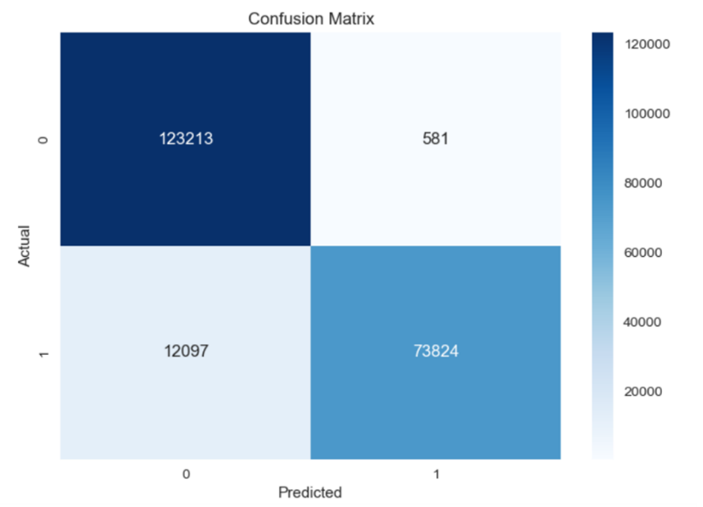

True Positives (TP): 73,824 True Negatives (TN): 123,213 False Positives (FP): 581 False Negatives (FN): 12,097

Logistic Regression Evaluation

* Accuracy: 93.95 %
* Precision: 99.21 %
* Recall: 85.92 %
* F1-score: 92.09 %
* AUC-ROC: 92.72 %

**Random Forest Classifier model:**

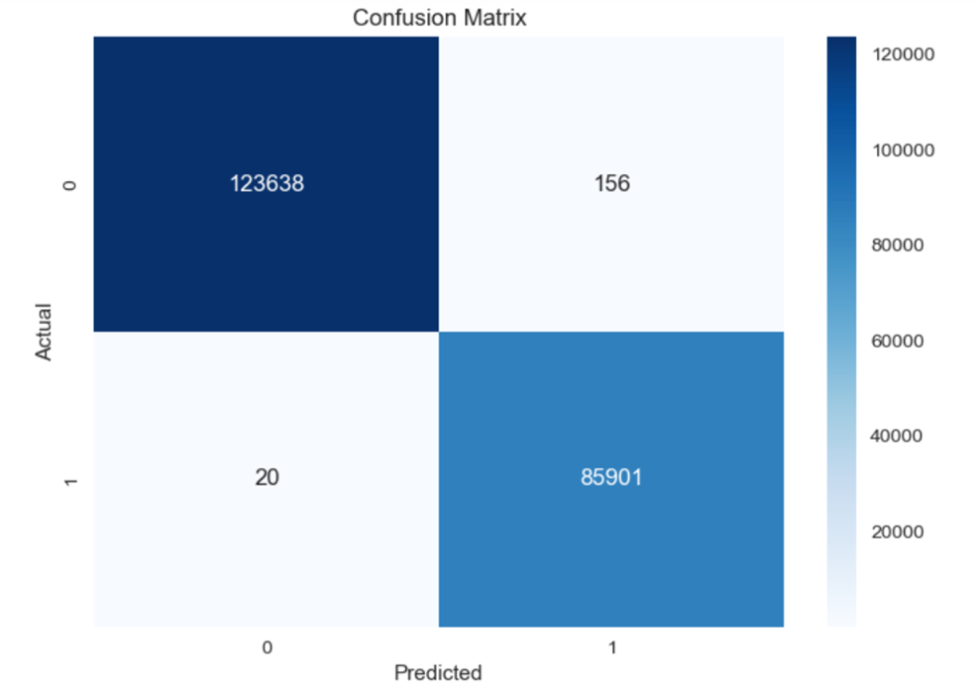

True Positives (TP): 85,901 True Negatives (TN): 123,638 False Positives (FP): 156 False Negatives (FN): 20

**Random Forest Classifier** Evaluation

* Accuracy: 99.91 %
* Precision: 99.81 %
* Recall: 99.97 %
* F1-score: 99.89 %
* AUC-ROC: 99.92 %

While the Random Forest Classifier model demonstrates higher true positive and true negative rates compared to the Logistic Regression, it also exhibits a lower count of false positives and false negatives. Specifically, the Random Forest Classifier model reduces false alarms (FP) from 581 to 156 and missed cases (FN) from 12,097 to 20. These improvements signify enhanced accuracy and reliability in predicting flight delays, underscoring the importance of continual model refinement and optimization to minimize errors and enhance operational efficiency.

**RECOMMENDATION**

For the business, it's crucial to adopt the Random Forest Classifier model due to its superior predictive performance, with higher true positives and true negatives and reduced false alarms and missed cases compared to the Logistic Regression. By implementing the Random Forest Classifier model, we can enhance our ability to accurately predict flight delays, leading to improved operational efficiency, better resource allocation, and enhanced passenger experience. Continual monitoring and refinement of the model will be essential to maintain its effectiveness over time.